MATHEMATICAL PRINCIPLES OF SETTINGS INSTEAD OF METHOD REGULARIZATION

E.N. Terentiev ¹, N.E. Terentiev ²
¹ Faculty of Physics, M.V. Lomonosov Moscow State University, 119992, Moscow, GSP-2, Sparrow hills, RUSSIA, en.teren@physics.msu.ru;
² HiQo Solutions, 135 Cedar St Richmond Hill, Georgia 31324, USA,
nikolay.terentyev@gmail.com

Mathematical Principles of Settings (MPS) transforms irregular Apparatus Functions (AF) sets to the regular sets invertible AF’s sets. MPS inversion of AFs gives us the non-smoothness solutions with the controlled maximum precision and extremely high resolution. The method regularization is based on assumption that the badly conditioned AF remains unchanged [1]. As result, we have the irreversible and smoothness solutions with the low precision. MPS extremely high resolution and regularization resolution are compared on the old radio-vision images in 3 mm wave range [2]. The method MPS may be embedded in the active radar or passive multi-rays radio-vision systems for resolving and for point indication of object-targets. There are numerous examples of the solutions to the model problems [8-9]. The method MPS will find wide applications in the geophysical investigations.

Tools and main MPS problem

The 2D mesh grid PAR=NDxDIAP is used in the MPS. Neutralization Distance (ND) is a width of the Window frame. Full Windowed picture with the frames is constructed in an even manner on tours. DIAP parameter specifies the constraint of MTF in the frequency domain [8-9].
MPS transforms irregular set of AF O to regular set AF pO and resolving function pR through 2D mesh grid PAR=NDхDIAP. Two sets: the prepared inverting pO and the resolving рR are obtained from the problem of generation tools of MPS in the contents of five blocks [8-9]:

(1)

The inputs parameters of the function ToolsMPS (1) are as follows: the original AF O with an Instrumental zero (error) Iz (interval abs()=1.e-13) and the mesh grid PAR=NDxDIAP. ToolsMPS output parameters are the contents in five blocks of ToolsMPS function: II there are Indicators of Inversions, MM - indicators of accuracy, FUN - Functions and their Norms Nor and Error block Err. The names of the first two blocks reflect roughly their contents.
The first block II contains: the Indicator of Inversions II (zR*O), the regularity indicator II (pR*pO), the mismatch indicator II (pR*O) and a direct accuracy indicator II (R*O) in the short calculations algorithms. The second block MM contains M(zR)M(O), which is an indicator of the bandwidth efficiency of Signal Processing System (SPS), if the resolution function zR=zO⁻¹ , where zO⁻¹is Iz inversion of AF O. M(pR)M(pO)==1 is an indicator of the total bandwidth for regular or reversible pR=pO⁻¹. M(pR)M(O) is an indicator of the bandwidth efficiency of SPS, when implementing the mismatch operation pR*O, which is presented by mismatch indicator II(pR*O). Indicator M(R)M(O) allow us to fix a cumulative calculation errors SPS in the long calculations algorithm. Errors themselves will be presented by the picture of the difference M(R)M(O)-1. The third Fun block contains the functions and the pairs of convolving functions. The fourth Nor block presents the norms of corresponding functions. The last fifth Err block presents with z and p prefix errors, which are fixed to the relative original AF O, instrumental zero (error) Iz and restriction DIAP.

Functions рО and pR are choosing from the solving main MPS problem:
… (2)
Problem (2) implements the most accurate results [3, 8-9] on the mesh grid PAR=NDxDIAP, through the using of ToolsMPS (1).

EXAMPLE OF MPS RESOLUTION

We compared discussed method on an image of the Sun received in 3 mm wave range. PSF O is given with error 3%. In order to receive extreme high quality result we Tools MPS transform (1) into PSF pO with limerr value 0.02%.
Err(O)=3%,  pO, limerr=0.02% | 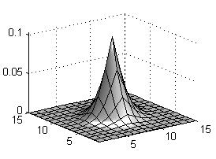 |  | 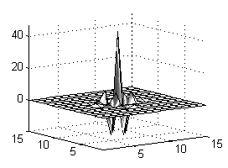  pR  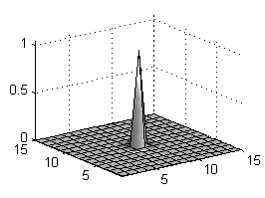  pR*pO=d
Image of the Sun, AF O, рО |  | Result, obtained with MPS
 | 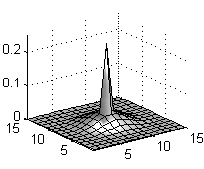  aO=aR⁻¹  Err(aO)=1.46 |  | 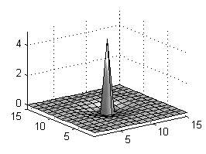  aR  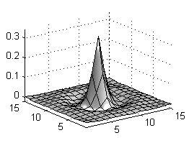  aR*O
Errors of regularization method |  | Results of regularization method

Fig. 1. Comparison MPS transform and regularization method

We received the extreme high resolution with resolved AF pR*pO=d (delta Kronecker function). Emphasize, regularized AF aR*O is related to regularized smooth image of the Sun. Residual results error 0.03 is due to Err(aO)=1.46.

Area of reversibility in a bandwidth SPS
We evaluate the bandwidth efficiency of SPS with MPS by the value:

M(R)M(O)=sum(M(R)*M(O))/N (3)

The sum of product (3) is calculated over all N points of bandwidth in the frequency domain. The value of M(R)M(O) measures the efficiency of using the bandwidth SPS.
Theorems about the bandwidth efficiency of SPS
For an invertible AF O and resolving function R=O⁻¹ in the ideal precise calculations we have two identity laws:

II(R*O)==M(R)M(O)==1 (4)

The identity laws (4) argue that reversibility takes place on the full bandwidth of the SPS.
If the calculations are realized with the Instrumental zero (error) Iz, then this instrumental error persists equality and inequality

II(zR*O)=M(zR)M(O)≤1 (5)

Inequality in (5) takes place in a mismatch error 1-pR*O>0, i.e. in the ToolsMPS (1). This means that the reversibility occurs in the part of in the bandwidth for SPS.
Theorem about reversibility: From the reversibility (or the Iz Inversion) II(zR*O)=1 implies direct reversibility II(R*O)=1, zR=R=O with the efficiency part M(zR)M(O)==1 and M(zR)*M(O)==1, which means that the numerical reversibility takes place in the whole bandwidth of the SPS.
Theorem about regularity: For regular pR = pO⁻¹ we have two identity laws II(pR*pO)==M(pR)M(pO)==1.
Theorem about errors: if M(R)M(O) is not equal one, than it means that we have a cumulative calculation errors SPS in a long calculation algorithm. But if R*O(0) is not equal one, than it means: AF O is very bad (MTF M(O) has many components in Iz ), or we have calculation errors SPS even in a shot algorithm.

CONCLUSION

We propose to redefine the in-situ problem “How to understand problems of inversion?” We propose the problems of inversion to consider on the regularized sets of MPS transformed or prepared AF pO (1). There is no “a priori solution smoothness” in MPS and therefore there is no a residual error.
REFERENCES

1 Тихонов, А.Н. & Уфимцев, М.В., 1988. Статистическая обработка результатов экспериментов, Изд-во МГУ.
2 Terentiev, E.N. & Terentiev, N. E., 2005. Application of pointed ultra-resolution method in microwave imaging, Proc. SPIE 5789, 167-177.
3 Пытьев, Ю. П., 2012. Методы математического моделирования измерительно-вычислительных систем, ФИЗМАТЛИТ.
4 Terentiev, E.N., Terentiev, N. E., & Shugaev, F. V., 2002. Forms of the images and indication of targets, Proc.SPIE 4541, 410-426.

5 Terentiev, E. N., Shugaev, F. V., Shtemenko, L. S., Dokukina, O.I. and Ignateva, O. A., 2006. Modeling of laser beam propagation through the whirlwind, Proc. SPIE 6215, 86-97.
6 Shugaev, F. V., Terentiev, E. N., Shtemenko, L. S., Nikolaeva, O. A., Pavlova, T. A. & Dokukina, O. I., 2007. On the problem of beam focusing in the turbulent atmosphere, Proc. SPIE 6747.
7 Terentiev, E.N., Terentiev, N. E. & Poluyanov,Yu. V., 2011. Super resolution, indication of 3D vector fields, The 8th Pacific Symposium on Flow Visualization and Image Processing, Moscow, Russia, August 21st-25th, 3ps.
8 Terentiev, E.N. & Terentiev, N. E., 2014. Mathematical Principles of Settings for measuring system, 7 th International Conference ACOUSTOOPTIC AND RADAR METHODS FOR INFORMATION MEASUREMENTS AND PROCESSING, September 15 - 17, 2014, Suzdal, Russia, PROCEEDINGS, pp 48-52.
9 Terentiev, E.N. & Terentiev, N. E., 2014. Mathematical Principles of Settings for multi rays system, ARMIMP Proc., pp 52-56.

