**Using airborne gravimeter GT2A in polar areas**

### Yu.L. Smoller, S.S.Yurist, I.P.Fedorova. "Gravimetric Technologies", Moscow

### [gravitech@mtu-net.ru](mailto:gravitech@mtu-net.ru)

### Yu.V. Bolotin, A.A. Golovan. Moscow State University, Moscow,

[ybolotin@yandex.ru](mailto:ybolotin@yandex.ru), [aagolovan@yandex.ru](mailto:aagolovan@yandex.ru)

V.N. Konjashev. Institute of Physics of the Earth, Moscow,

[slavaconeshov@hotmail.com](mailto:slavaconeshov@hotmail.com)

**W. Hewison.** Сanadianmicrogravity, Victoria Park, **Australia**

[wayne@canadianmicrogravity.com](mailto:wayne@canadianmicrogravity.com)  
T. Richter, J. Greenbaum, D. Young, D. Blankenship. University of Texas, Austin TX USA [tom.richter@utexas.edu](mailto:tom.richter@utexas.edu) [jamin@utexas.edu](mailto:jamin@utexas.edu) [blank@ig.utexas.edu](mailto:blank@ig.utexas.edu).

**Abstract**

*Key words: airborne gravimetry, polar areas, quattro GPS receiver, orientation*

*The paper discusses a modification made to the airborne gravimeter GT-2A for operation in polar areas. The all-latitude version of the gravimeter GT-2AP (P stands for polar) employs the four antenna GPS receiver Javad QUATTRO-G3D. This receiver is automatically self-calibrated to construct the so-called GPS coordinate frame, tied to the aircraft body. During flight the receiver delivers the orientation matrix of the platform. The paper presents results of an airborne survey in polar areas with GT-2AP and provides a comparison of operation of GT-2A and GT-2AP at high latitudes.*

The gravimeter GT-2A [1] employs a gyro stabilized unperturbed (Shueler-tuned) platform in a three axes gimbaled suspension with vertical external axis. The platform carries the gravimetric sensor with vertical sensitivity axis, two horizontal accelerometers, a dynamically tuned gyroscope with vertical rotation axis, and a fiber-optic gyro sensor of vertical angular rate, the latter with mediocre accuracy. The gimbal rings are operated with torque motors using electromagnetic angle sensors. Based on the signals fed to the torque sensors of the dynamically tuned gyroscope, the platform navigation system computes the gyroscopic heading of the platform.

The price paid for the Shueler property of the platform is the necessity in using aiding information on the aircraft velocity in real time. The platform is damped during the flight using information on the aircraft velocity in the platform coordinate frame. For this purpose the single antenna GPS receiver velocity solutions $V_{E}^{*}$, $V_{N}^{*}$ delivered in the local geodetic frame are projected on the azimuth free platform axes using the computed value of the gyroscopic heading. The relations between the coordinate frames are shown in the diagram. The calculations are done as

$U_{xa}=p_{xa }-\frac{V_{ya}^{*}}{R}$, $U_{ya}=q_{ya }-\frac{V_{xa}^{*}}{R}$, $A=\tan^{-1}{\frac{U_{xa}}{U_{ya}}}$,

$$V_{ya}^{*}=V_{N}^{*}\cos{A+}V_{E}^{*}\sin{A,}$$

$$V_{xa}^{*}=V_{E}^{*}\cos{A-}V_{N}^{*}\sin{A}$$

Here $p_{xa }, q_{ya }$ are the signals at the torque sensors of the dynamically tuned gyroscope, $V_{xa}^{*}$, $V_{ya}^{*}$ are the calculated velocity in the free azimuth platform frame, $U_{xa}$, $U_{ya}$ are the calculated projections of the Earth angular velocity on the azimuth free platform axes, $A$ is the azimuth of the free azimuth platform frame. When the flight latitude increases, the errors of the gyroscopic heading calculation increase, as well as misalignment errors of the vertical, deteriorating the platform damping and making operation of GT-2A in polar areas impossible. Experience of high latitude surveys show that the platform leveling errors rapidly increase at latitudes over 750 [2].

The error $∆K$ of the calculated gyroscopic heading can be written as

$∆K=\frac{{∆p}_{E}+{\dot{α}}_{E}}{(U+\dot{λ)}\cos{φ}}$ (1)

Here ${∆p}_{E}$ is the eastern component of the drift of the dynamically tuned gyro, ${\dot{α}}_{E}$ is the eastern angular velocity error of the gyro vertical, $U$ is the angular rate of the earth, $\dot{λ}$ is the longitude derivative in time, $φ$ is the geographic latitude.

Equation (1) yields the following observations:

1. When the flight latitude increases, the error $∆K$ of the gyroscopic heading calculation increases. When the aircraft flies near the pole, the error tends to infinity, since the denominator in (1) tends to zero. This effect deteriorates the platform damping and makes operation of GT-2A in polar areas impossible. Experience of high latitude surveys show that the platform leveling errors rapidly increase at latitudes over 800.
2. When the aircraft flies toward the West, the latitude derivative in time $\dot{λ}$ is negative, leading to bigger heading errors than when the aircraft flies toward the East. This effect is especially noticeable in high latitudes where the longitude derivative is comparable with Earth angular velocity. When the aircraft flies toward the West, the denominator in (1) can become zero at the latitudes lower than 800.

With the gyroscopic heading errors explained above the error $∆V$ in the aircraft velocity $V_{xa}^{*},$ $V_{ya}^{*}$ in the platform free azimuth frame is dominated by the term $∆V=V∆K.$ When this term increases at higher latitudes, the external information on velocity in the platform frame looses accuracy, which yields platform misalignment with increasing ${\dot{α}}_{E}$. Looking again at (1), we see that increase of ${\dot{α}}_{E}$ leads to further increase of heading errors as well, followed by instability of the platform. This reasoning, aided with experimental results, show that the platform leveling errors rapidly increase at latitudes over 750, .making gravity surveying impossible [3].

To sum up, we point out that the single antenna GPS receiver is a very accurate velocity sensor, but this accuracy is achieved in the not proper coordinate frame. The idea here is to use a four-antenna GPS receiver. Such receiver delivers information on velocity $V_{g}$ in the Earth-Centered-Earth-Fixed (ECEF) frame plus an estimate of the orientation matrix $B_{4g}$ of the antenna quadruple frame relative to the ECEF frame.

The orientation matrix of the aircraft frame relative to the platform frame is calculated using the data $A_{x}$, $A_{y}$, $A_{z}$ from the angle sensors of the gimbal rings of the platform as follows.

$$B_{sp}=\left[\begin{matrix}\cos{A_{z}}\cos{A_{y}} & \sin{A_{z}}\cos{A_{x}+\cos{A_{z}\sin{A_{y}\sin{A_{x}}}}} & \sin{A_{z}}\sin{A_{x}-\cos{A_{z}\sin{A_{y}\cos{A_{x}}}}} \\ -\sin{A_{z}}\cos{A_{y}} & \cos{A_{z}}\cos{A_{x}-\sin{A_{z}\sin{A_{y}\sin{A_{x}}}}} & \cos{A_{z}\sin{A_{x}+\sin{A_{z}}}}\sin{A_{y}}\cos{A_{x}} \\ \sin{A_{y}} & -sin{A_{x}}\cos{A_{y}} & \cos{A_{x}}\cos{A_{y}}\end{matrix}\right]$$

The orientation matrix of the free azimuth coordinate frame relative to the platform frame is calculated using the azimuth angle delivered by integrating the vertical fiber optic gyro readings as follows

$B_{ap}=\left[\begin{matrix}\cos{C} & \sin{C} & 0 \\ -\sin{C} & \cos{C} & 0 \\ 0 & 0 & 1\end{matrix}\right]$, $C=\int{r_{a}dt}$

The orientation matrix $B_{s4}$ of the aircraft frame relative to the four-antenna frame is calculated during the initial alignment of the platform at the airport as ${B_{s4}=B_{sp}B_{pg}B}_{4g}^{T}$, where the matrix $B_{pg}$ is delivered by the initial alignment algorithm. With the above matrices computed, the aircraft velocity in the free azimuth coordinate frame during the flight can be calculated as

$$V_{a}={B_{ap}B}_{sp}^{T}B_{s4}B_{4g}V_{g}.$$

The all-latitude version of the gravimeter GT-2AP (P stands for polar) employs the four antenna GPS receiver Javad QUATTRO-G3D. This receiver is automatically self-calibrated to construct the so-called 4-antenna coordinate frame, tied to the aircraft body. During flight the receiver delivers the orientation matrix of this frame and the aircraft velocity relative to the ECEF frame.

During self-calibration at the aerodrome the onboard software of GT-2AP determines relative orientation matrix of the aircraft coordinate frame and the GPS-derived frame. During flight GT-2AP employs this matrix to combine the GPS velocity and the gimbal angular sensors data in calculating the gyro platform damping signals.

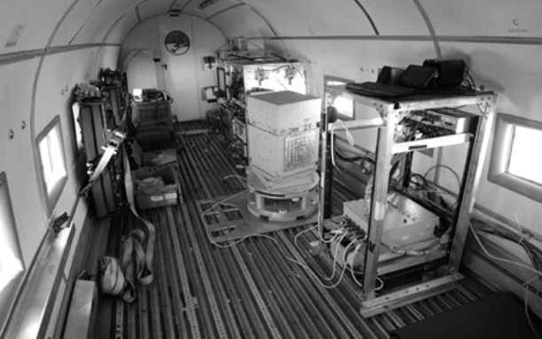

Figure 3

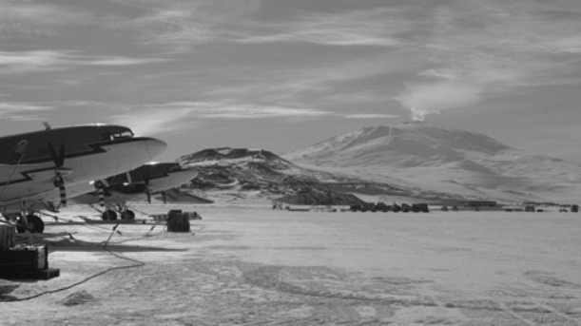

Figure 2

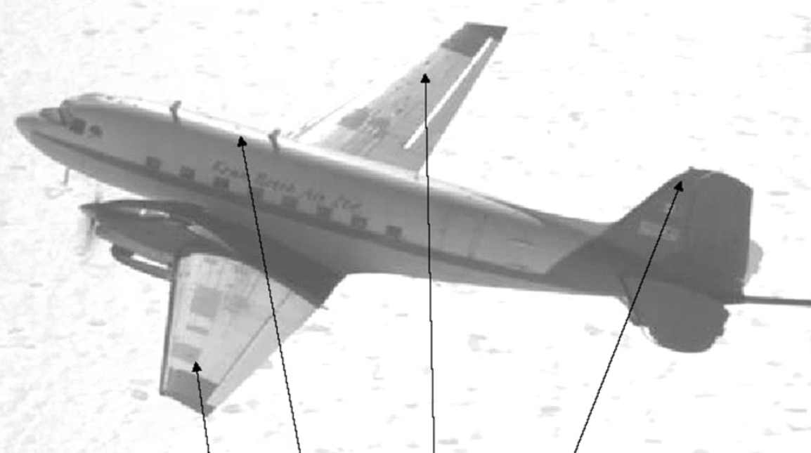

Figure 4

The proposed approach takes off the latitude constraints and allows to operate GT-2AP on the whole Earth including the poles. The paper presents results of an airborne survey in polar areas with GT-2AP and provides a comparison of operation of GT-2A and GT-2AP at high latitudes.

In 2012 – 2013 the Texas University did gravimetric surveys in the Antarctic with the gravimeter GT-2AP onboard the DC-3 aircraft. In 2012-2013 the Institute of Physics of the Earth did gravimetric surveys in the Arctic with the gravimeters GT-2A and GT-2AP onboard the AN-26 aircraft.

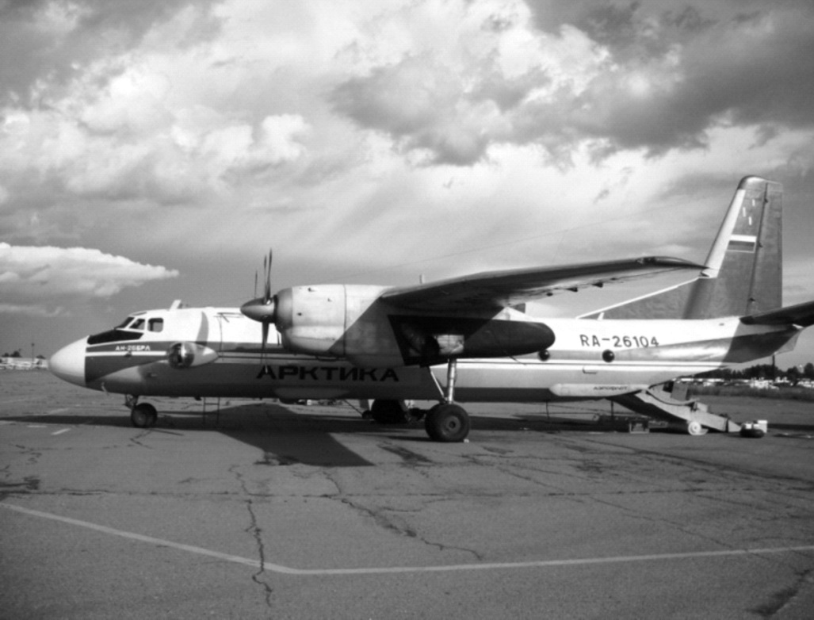

Figure 5

Figure 2 shows DS-3 with the Erebus volcano in the background. Figure 3 shows GT-2AP onboard DS-3. Figure 4 shows GPS antennas positions on DC-3. The distance between antennas in the nose-tail direction is 11m, the distance between antennas in the left wing-right wing direction is 22m.

Figures 5,6 show the AN-26 aircraft and the gravimeter GT-2AP onboard. Gravimeters GT-2A onboard are not shown in the picture. All four antennas where mounted inside the body of the aircraft. The master antenna was mounted under special blister as shown in figure 7, other antennas where positioned in the pilot cabin. The nose-tail distance between antennas was 3m, the right wing-left wing distance was 1.5m..

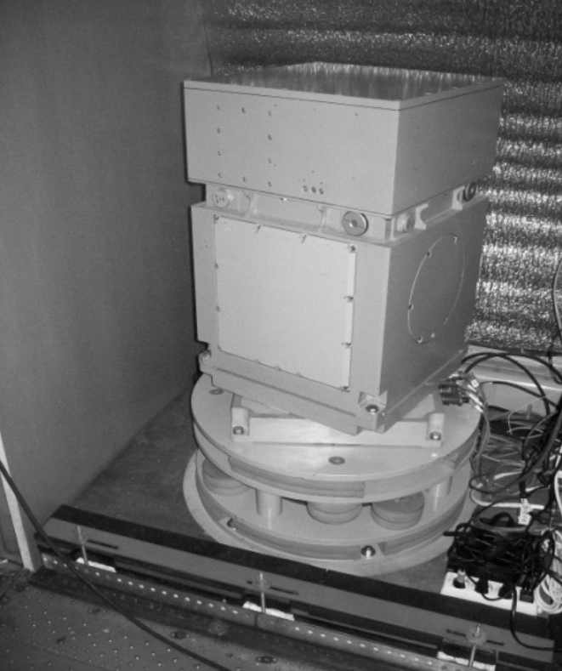

Figure. 6

Figure 8 shows one flight path in the Antarctic. The airport was based at 800,latitude, the survey lines were at 77-780.latitudes. The flights duration was about 7 hours with average velocity of 200 knots. Figure 9 shows the East and North velocities at top and the platform misalignment angles at the bottom, both evaluated in post-mission mode. From the top graph one can see that the East and West velocities were up to 150 knots, which is close to the Earth rotation speed at these latitudes. In this case the heading can’t be calculated using the gyro compass approach, since the denominator in (1) tends to zero. Thus the GT-2A instrument couldn’t be used in this survey. However, GT-2AP performed well, with platform misalignment not exceeding 1-2 arc minutes.

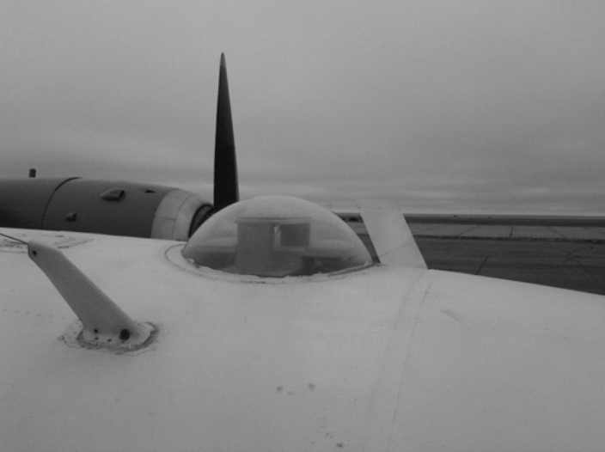

Рис.7

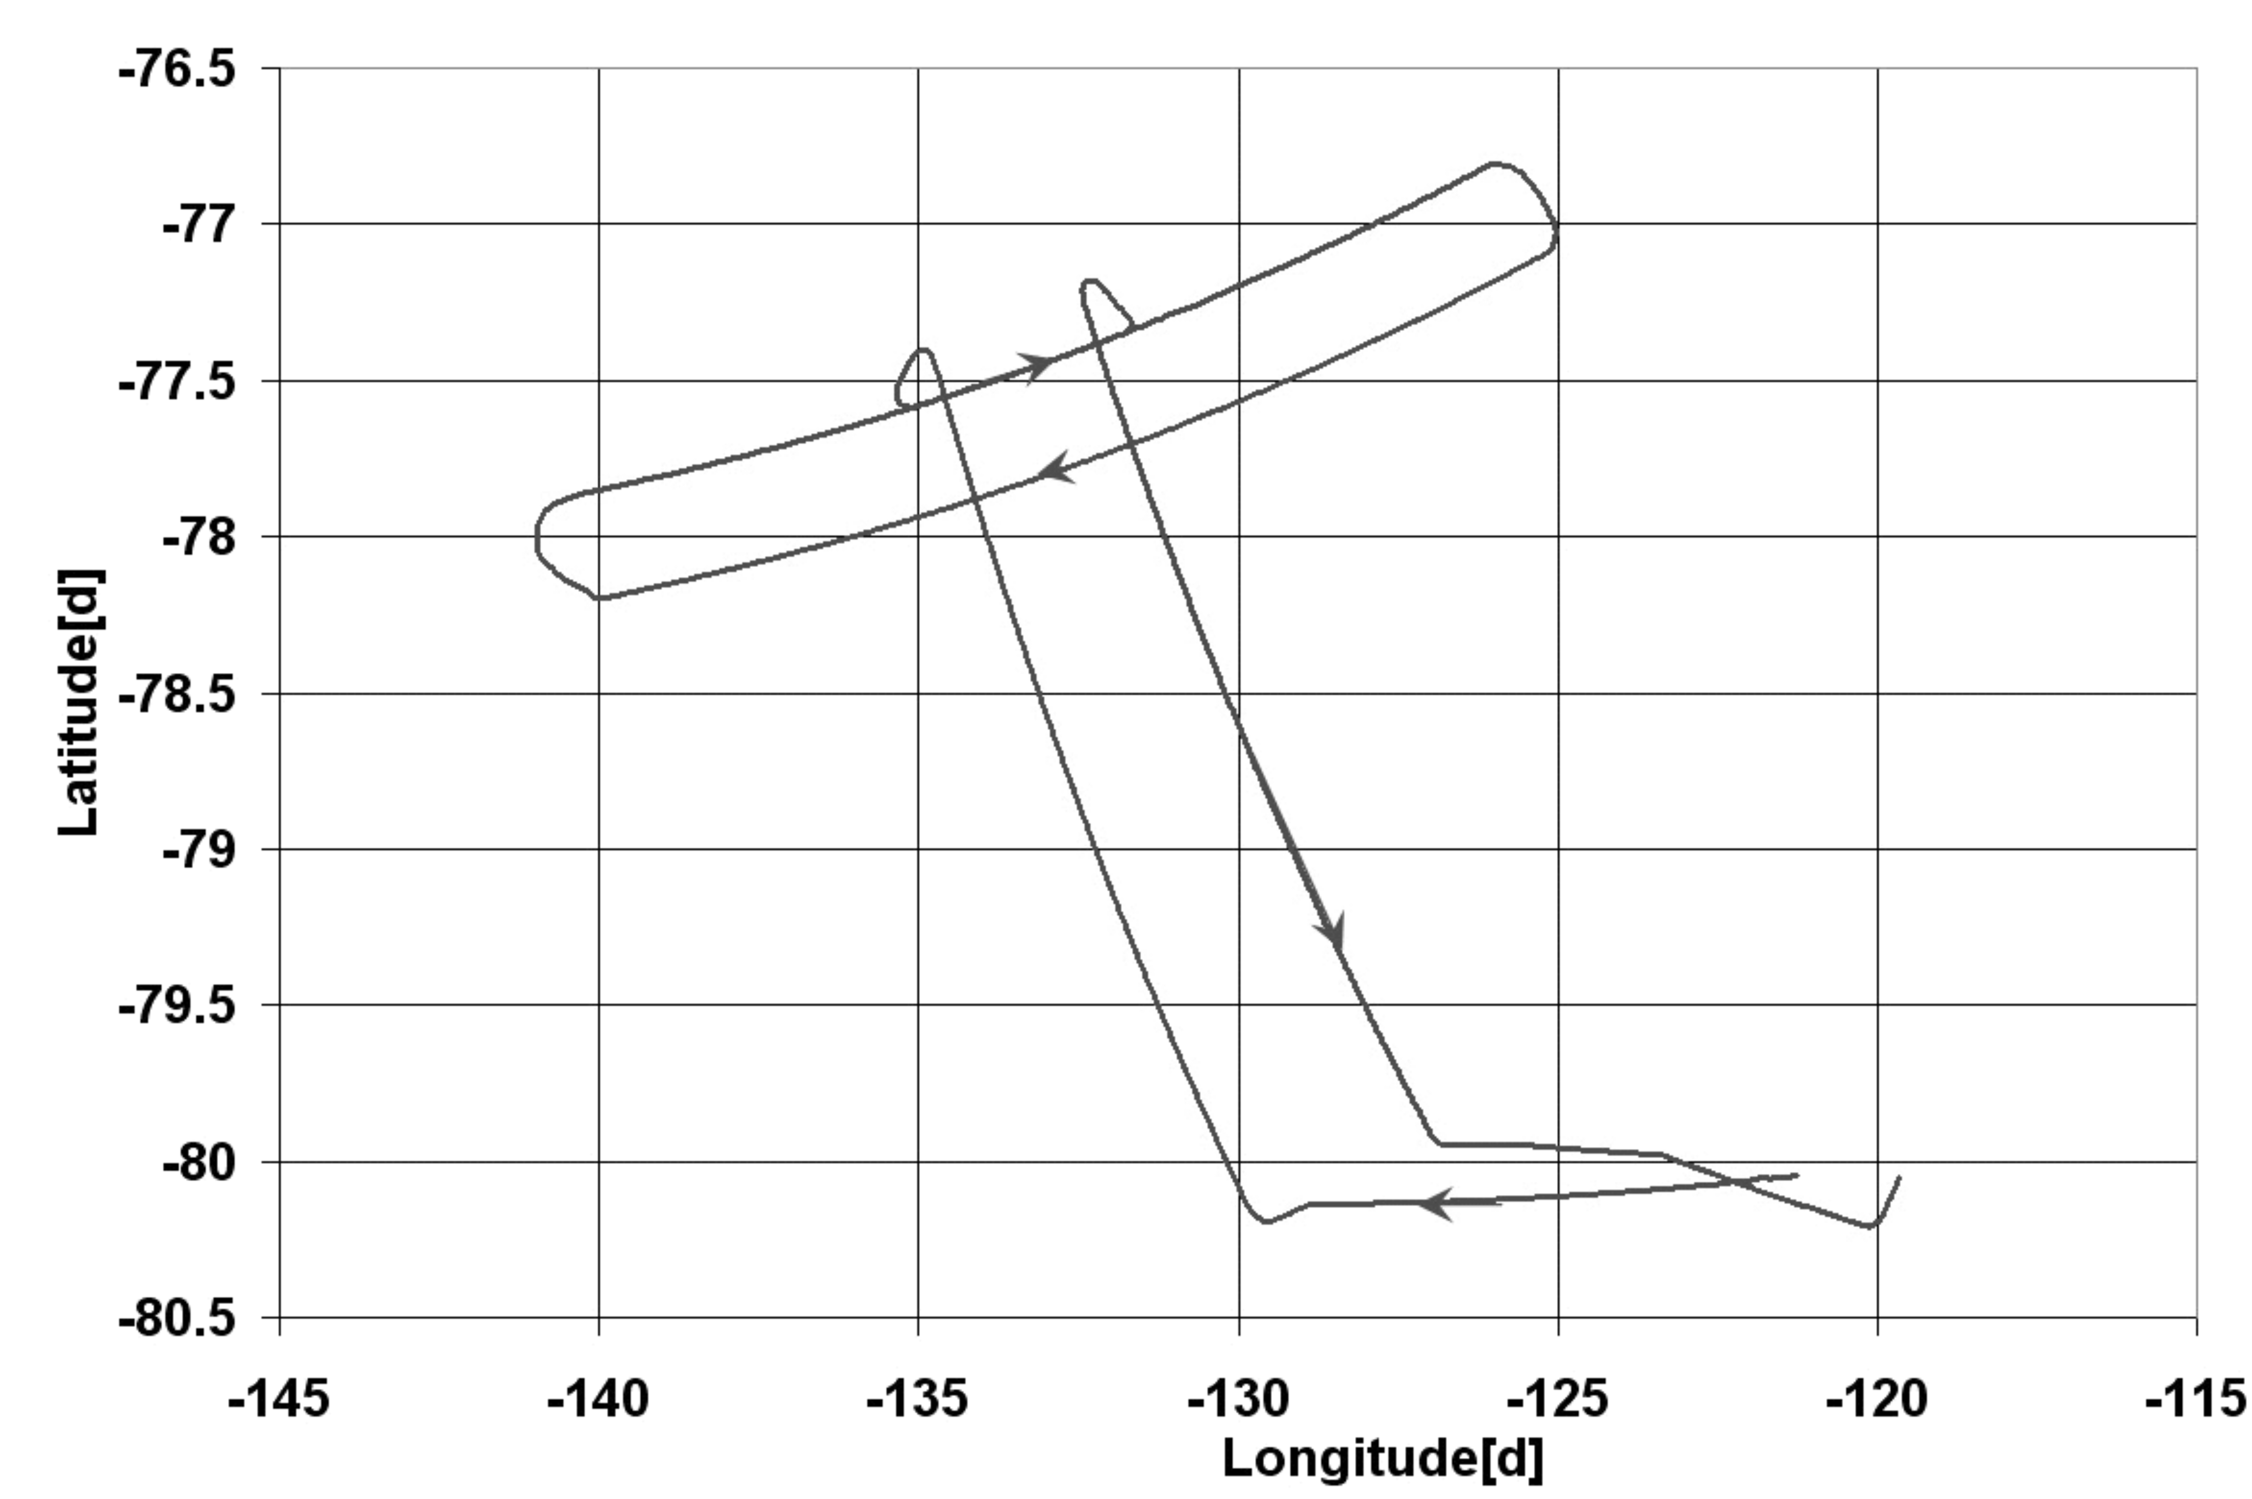

Рис. 8

Figure 10 presents the path of one of the flights in the Arctic..The aircraft AN-26 left the airport Anderma at 700, latitude, reached 780 ,latitude, turned, reached the initial airport position without landing, flew toward the West, landing finally at the Archangelsk airport at 650 .latitude. The flight duration was seven hours; the flight speed was about 200 knots.

Figure 11 shows some results of this flight. The top graph shows the platform misalignment errors for two GT-2A instruments with one GPA antenna. The lower graph shows the platform misalignment errors for GT-2AP with four GPS antennas. The graphs prove that at high latitudes the misalignment errors of GT-2AP are three times lower than that of GT-2A in similar conditions.

As a conclusion, we note that the polar modification of GT-2A called GT-2AP and equipped with a four-antenna GPS receiver showed platform misalignment errors at high latitudes three times less than that of GT-2A with one GPS antenna. The tests done in the Arctic and in the Antarctic proved the polar version ready for gravity surveys around the whole globe.

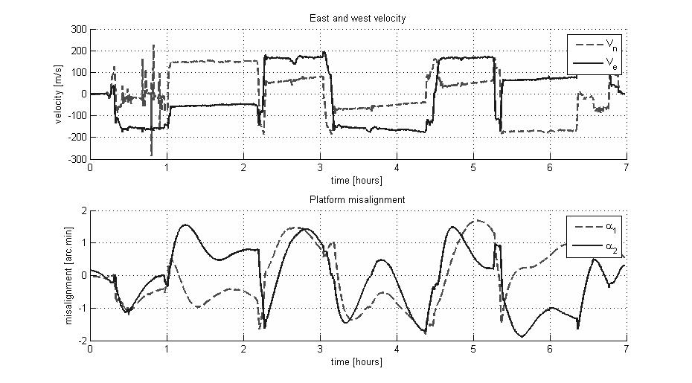

Figure 9

**References**

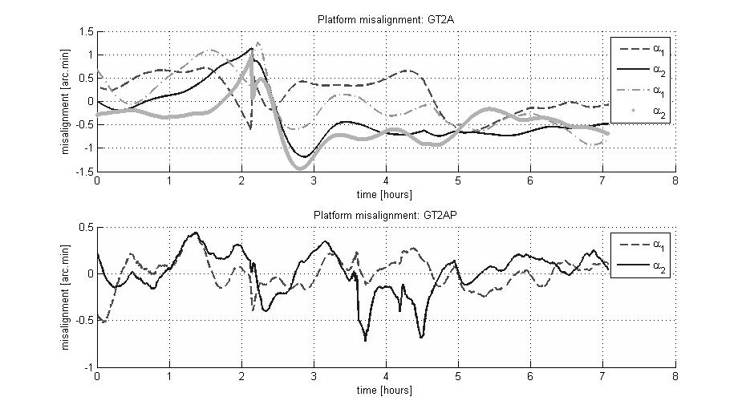

Figure 11.

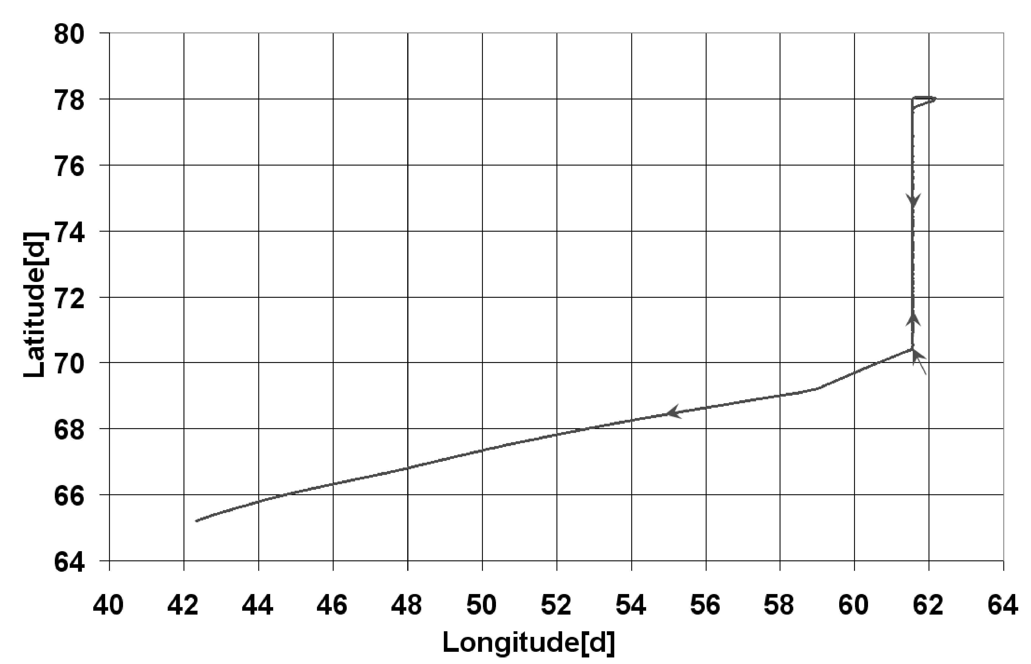

Figure 10.

1. Berzhitsky V. N., Bolotin Yu. V., Golovan A. A., Iljin V. N., Parusnikov N. A., Smoller Yu. L., Yurist S.Sh. GT-1A inertial gravimeter system. Results of flight tests. Moscow: Center of Applied Research Publishing House, Faculty of mechanics and mathematics, MSU, 2002, 40 p.
2. Koneshov, V.N., Koneshov, I.V., Klevtsov, V.V., Makushin, A.V., Smoller, Y.L., Yurist, S.S., Bolotin, Y.V., Golovan, A.A. An approach to refined mapping of the anomalous gravity field in the Earth's polar caps (2013) Izvestiya, Physics of the Solid Earth, 49 (1), pp. 77-79.
3. Bolotin, Y.V., Yurist, S.S. Suboptimal smoothing filter for the marine gravimeter GT-2M (2011) Gyroscopy and Navigation, 2 (3), pp. 152-155.