Magnetic properties variations in iron complexes with benzimidazole derivatives depending on the system spin state
Khenkin L.V. ^{1, a}, Novakova A.A. ^{1, b}, Perov N.S. ^{1, c}, Vompe A.A. ^{1, d}
¹ Physics Department of Lomonosov MSU, Leninskie Gory, 1, Moscow, 119991, Russia
ªlevkhenkin@gmail.com, ^{b}novakova.alla@gmail.com, ^{c}perov@magn.ru, ^{d}tevo@yandex.ru
Keywords: Spin crossover phenomenon; iron-organic complexes; Mossbauer spectroscopy; magnetic properties; bezimidazole based ligands
Abstract. Complexes of bivalent and trivalent iron with ligands based on benzimidazole derivatives have been synthesized and investigated. Chloride-ion was used as anion. Samples ligands differed from each other in the length of alkyl radical. Some samples were found in a mix-valence state, that complicated spin transition observation. Combination of Mossbauer spectroscopy and magnetic moment in high field (15kOe) measurements in the temperatures range 130K - 350K allowed us to establish the valence of iron ions under spin transition in our samples and spin transition temperature frameworks for these mix-valence compounds.
Introduction
Spin crossover (SCO) materials with iron (bivalent or trivalent) central ion represent amazing class of bistable materials [1-3]. In these systems iron central cation can switch its state from low spin (LS) to high spin (HS) under external perturbations such as temperature, pressure, magnetic field, light irradiation and others. Among the big variety of potential practical applications of SCO materials there are developments of temperature and pressure sensors, optical elements of displays, data storage cells, contrast agents for MRI [4-7].
Magnetic, optical, structural properties of such compounds change simultaneously with iron ions spin state switching. In the case of bivalent iron ions the compound transforms from diamagnetic state with S=0 to paramagnetic with S=2. For trivalent iron ions spin alter from S=1/2 to S=5/2. To define each temperature spin transition we must reveal spin transition curve - temperature dependence of the high-spin mole fraction.
Our work studies first synthesized iron complexes with benzimidazole based ligands. Chloride-ion was used as anion. Samples differed from each other by length of alkyl substituent chain, connected to ligand.
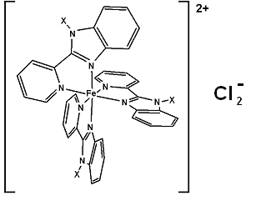
The aim of our work was to find out influence of alkyl substituent chain length on the temperature interval of thermal spin transition and on the samples oxidation stability. Influence of Fe²⁺/Fe³⁺ ratio on the spin transition properties was investigated also.
Experimental
Two samples of new iron complexes with benzimidazole derivatives were synthesized by the way described in [8]. Structural formula of synthesized compounds is shown in fig. 1. Chloride-ions were used as anions. Alkyl radical connected to ligand is denoted in the figure as X. For the sample 1 alkyl substituent was C₆H₁₃ and for the sample 2 - C₁₆H₃₃. Both samples have black color, but sample 2 has dark red shade.
Fig. 1. Structural formula of the samples under investigation
Mossbauer spectroscopy provides accurate identification of qualitative and quantitative analysis of phases containing iron. It is the most sensitive method for iron spin and valence state identification [9]. Mossbauer spectra were obtained at the temperatures 130K and 300K in traditional transmission geometry. Co57(Rh) was used as γ-radiation source. Analytical fitting was carried out using UNIVEM MS 2006 software.
To determine more precisely temperature framework of spin transition magnetic measurements were carried. Temperature dependences of samples magnetic moment in high magnetic field were obtained on the vibrating sample magnetometer (LAKE SHORE 7407) in the temperature range from 80 up to 350K. The dependences were plotted using magnetic moment values obtained in the field H=15kOe after mathematically processing magnetic curves (magnetic curves were treated by least square method with Langevin function approximation).
Results and discussion
Mossbauer spectra of the samples under investigation obtained at the temperatures 130K and 300K consist of several doublets (fig. 2). From Mossbauer spectra parameters fitting it was found that both samples contain bivalent and trivalent iron ions. The doublets of bivalent iron ions are characterized by the next parameters: isomer shift δ = 0.34-0.41 mm/s, quadrupole splitting Δ_{EQ} = 0.35-0.45 mm/s corresponds to the LS state and δ = 0.9-1.1 mm/s, Δ_{EQ} = 2.0-2.3 mm/s for HS state ions. For trivalent iron ions: δ = 0.34-0.41 mm/s and Δ_{EQ} = 1.37-1.43 mm/s for the LS state doublet, δ = 0.28-0.35 mm/s and Δ_{EQ} = 1.37-1.43 mm/s for the HS state doublet.
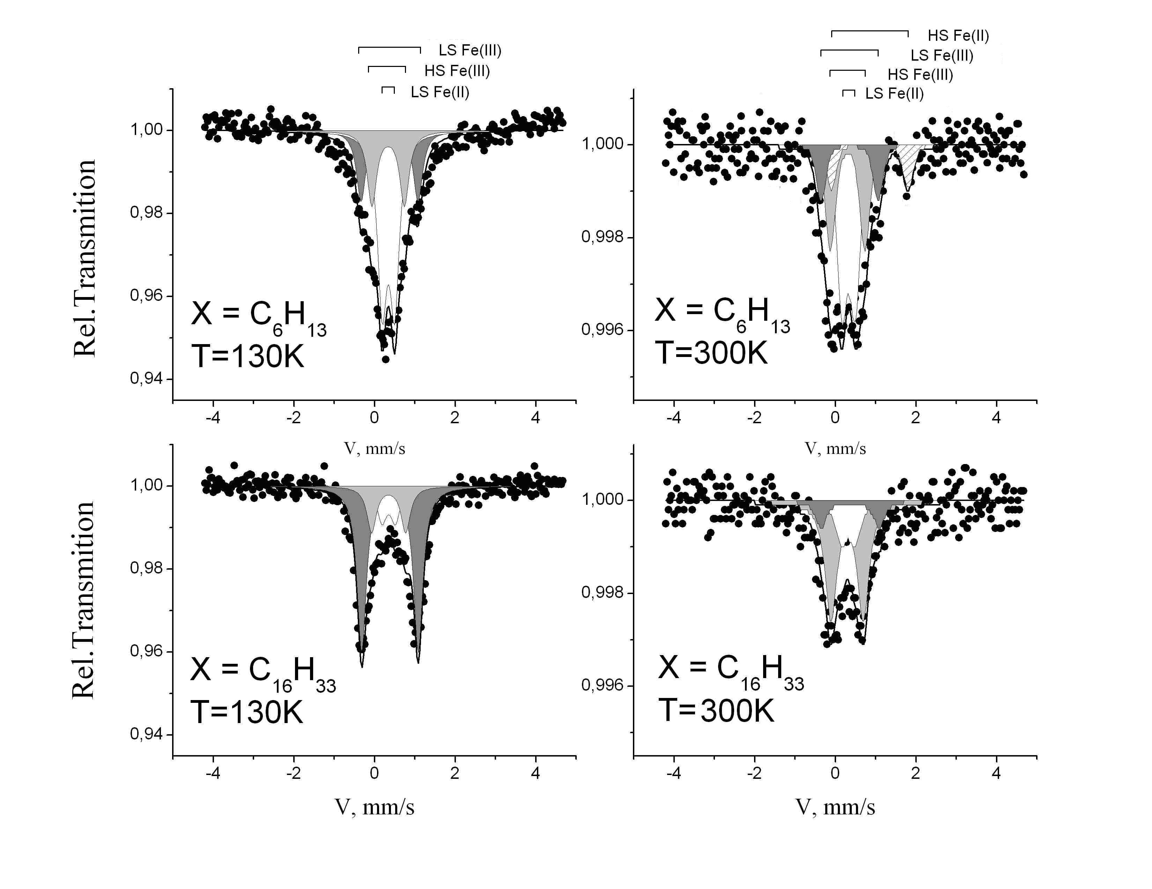
Fig. 2. Mossbauer spectra of: sample 1 (at the top) and sample 2 (at the bottom)

It must be mentioned that bivalent iron ions at investigated temperatures are mainly in low-spin state. But spin state changing of bivalent iron was observed only for sample 1. Thermal spin transition for sample 2 begins at higher temperature. The relative quantities of iron spin states are shown in table 1.
Sample | Alkyl radical | T = 130K |  |  |  | T = 295K
Sample | Alkyl radical | Fe(II) |  | Fe(III) |  | Fe(II) |  | Fe(III)
Sample | Alkyl radical | LS, % | HS, % | LS, % | HS, % | LS, % | HS, % | LS, % | HS, %
Sample 1 | C₆H₁₂ | 46 | 0 | 29 | 25 | 44 | 12 | 15 | 29
Sample 2 | C₁₆H₃₃ | 16 | 0 | 67 | 17 | 21 | 0 | 12 | 67
Table 1. Mole fraction of Fe ions spin and valence states in the investigated samples

The appearance of trivalent iron in the samples under investigation may be explained by chloride-ion anion effect. It was established from Mossbauer spectra fitting that sample 1 contains 40±5% Fe(III) in the total iron amount, while sample 2 with long alkyl radical length contains 80±5% Fe(III). SCO phenomenon was observed for trivalent iron ions in both samples, but for the sample 2 thermal spin transition is more sharp: 75% of low spin Fe(III) transforms to high-spin state at room temperature.
Temperature dependence of magnetic moment in the high field(15 kOe) is shown in fig. 3. The magnetic moment magnitude decreases in correspondence with Curie-Weiss law. Magnetic moment curve has a peculiarity at the temperature T=250±5 K: the value increases for about 30 memu/g at this temperature (these measurements were repeated several times to exclude the error points). This peculiarity can be explained by spin transition beginning for the Fe(III) ions.
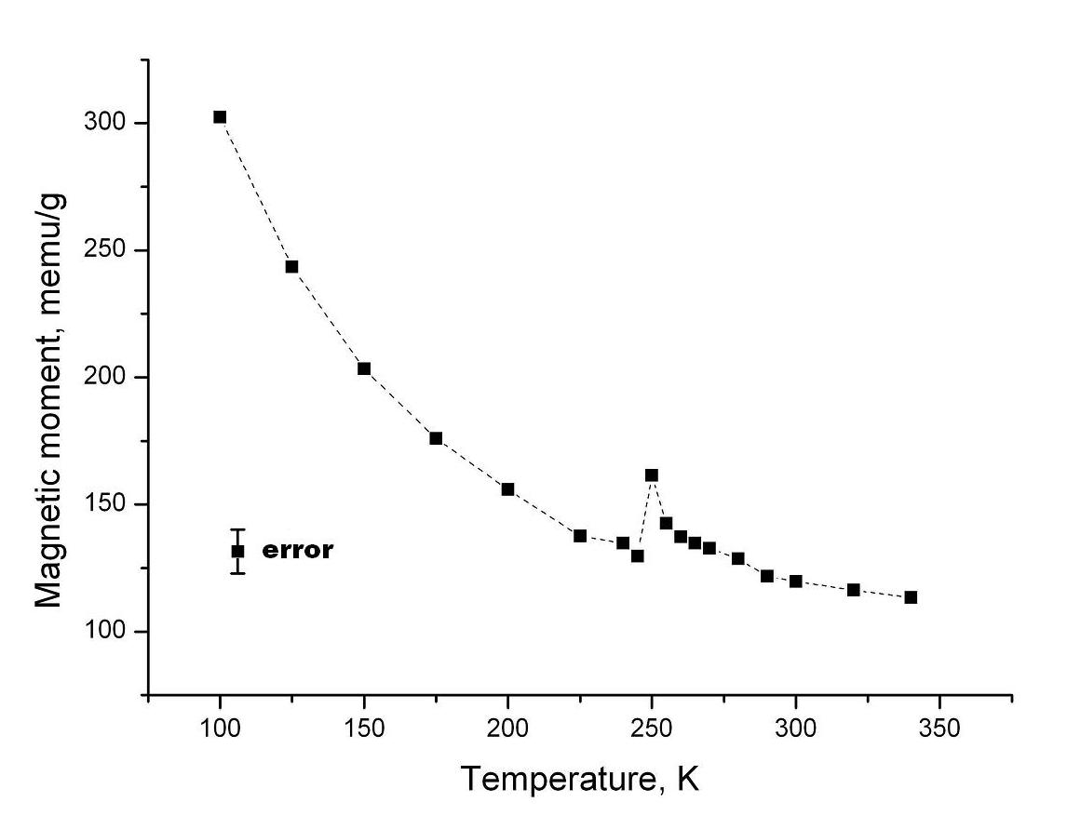
Fig. 3. Temperature dependence of magnetic moment in high field (15 kOe) for sample 1
Magnetic moment temperature dependence in the magnetic field H=15 kOe for sample 2 is shown in fig. 4. The absolute values of magnetic moment are less than in sample 1 in accordance with Mossbauer data due to lower iron ions concentration and a larger amount of high-spin fraction at low temperatures. Temperature of spin transition beginning is established as T=270±5 K. Increasing of magnetic moment at the peak temperature is about 50 memu/g, that is bigger than in sample 1 despite the lower iron ions concentration and occurred in the wider temperature region. It may be explained by the fact that the content of trivalent iron ions involved in spin transition in sample 2 is greater than in sample 1 as it was shown by means of Mossbauer spectroscopy.
Summary
The oxidation and spin states of two new iron complexes with benzimidazole derivatives were established by means of Mossbauer spectroscopy and magnetic measurements. Both bivalent and trivalent compounds underwent thermal spin transition. For trivalent iron ions transition temperature region begins at T=250K for sample 1 and for sample 2 with long alkyl substituent chain this temperature is 270K. This fact can be utilized in thermal sensor devices development.

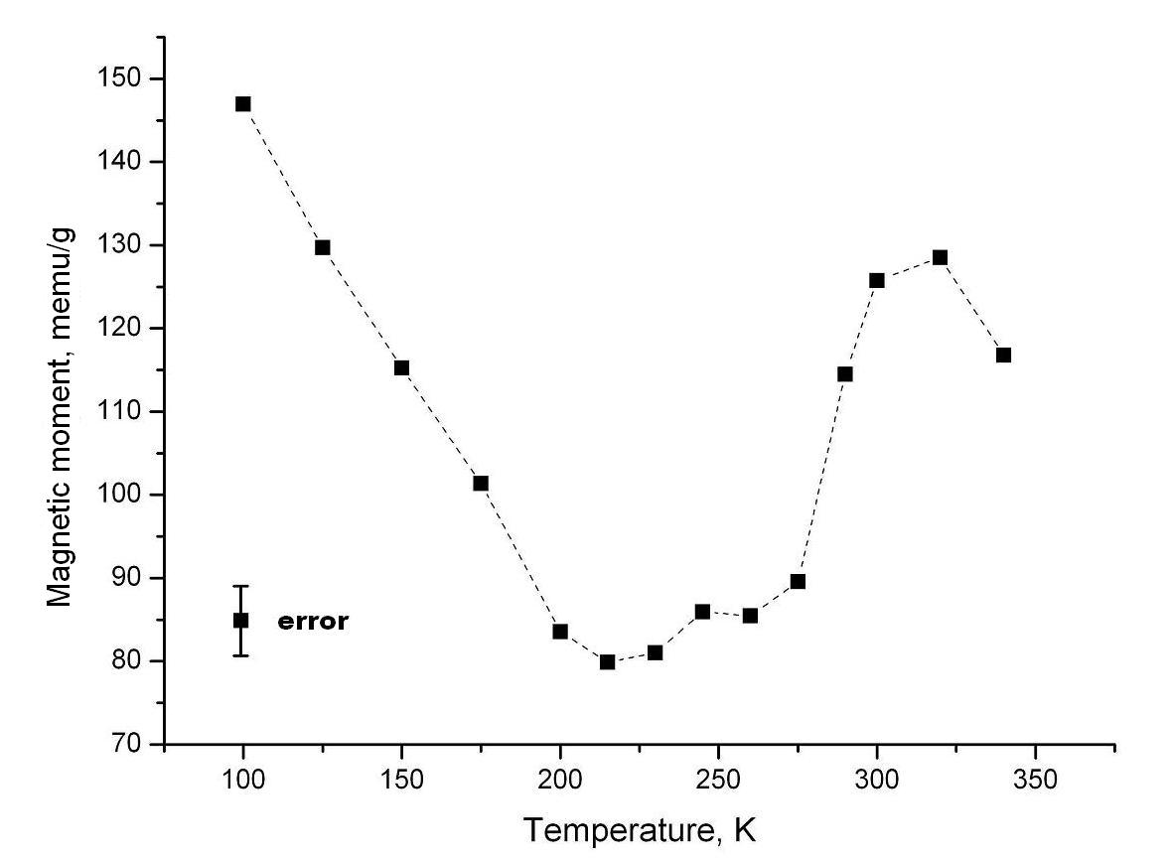
Fig. 4. Temperature dependence of magnetic moment in high field (15 kOe) for sample 2
References
[1] P. Gutlich, H. Goodwin, Spin crossover—an overall perspective, Top. Curr. Chem. 233 (2004) 1–47.
[2] A. Bousseksou, G. Molnar, L. Salmon, W. Nicolazzi, Molecular spin crossover phenomenon: recent achievements and prospects, Chem. Soc. Rev. 40 (2011) 3313–3335.
[3] J. Real, A. Gaspar, M. Munoz, Thermal, pressure and light switchable spin-crossover materials, Dalton Trans. 10 (2005) 2062–2079.
[4] J Letard, P. Guionneau, L. Goux-Capes, Towards spin crossover applications, Top. Curr. Chem. 235 (2004) 221–249.
[5] Y. Garcia, V. Ksenofontov, P. Gutlich, Spin Transition Molecular Materials: New Sensors, Hyperfine Interactions 139 (2002) 543–551.
[6] O. Kahn, С. Martinez, Spin-transition polymers: from molecular materials toward memory devices, Science 279 (1998) 44-50.
[7] V. Stavila, M. Allali, L. Canaple, Y. Stortz, C. Franc, P. Maurin, O. Beuf, O. Dufay, J. Samarut, M. Janier, J. Hasserodt, Significant relaxivity gap between a low-spin and a high-spin iron(II) complex of structural similarity: an attractive off–on system for the potential design of responsive MRI probes, New J. Chem. 32 (2008) 428–435.
[8] L.V.Khenkin, A.A.Novakova, T.Yu.Kiseleva, V.V.Sotsky, N.V.Usol’tseva, Temperature spin transition in new iron complexes with benzimidazole derivatives, Mos. Univ. phys. Bull. Series 3. Physics and astronomy 6 (2009) 57-59.
[9] R. Boca, M. Boca, H. Ehrenberg, H. Fuess, W. Linert, F. Renz, I. Svoboda, Spin crossover in iron(II) tris(2-(2’-pyridyl)benzimidazole) complex monitored by variable temperature methods, Chem. Phys. 293 (2003) 375–395.

